# Detection of Knee Osteoarthritis and its Severity

Dr. G Senthil Kumar#1 Muthu Annamalai.V #2, KOULURU NANDA KISHORE REDDY #3, Mukesh Kumar. S #4

“Department of Computer Science and Engineering”,

Panimalar Engineering College, Chennai, Tamil Nadu 600123, India.

1mailtosenthilkumar@yahoo.com[2muthuannamalai2002@gmail.com](mailto:2muthuannamalai2002@gmail.com), [3nandakouluruemail@gmail.com](mailto:3nandakouluruemail@gmail.com), 4mukeshkulikkari@gmail.com

Abstract— **Knee Osteoarthritis (OA) can be defined as a medical illness impacting the knee joint that is caused by wear and tear on the cartilage that results in pain. Experienced radiologists grade the severity of the impairments based on standardized grading systems such as KL (Kellgren–Lawrence) grading schemes or other grading schemes as determined by the radiologists. To prevent knee OA from progressing in severity, the condition must be detected and classified early on in patients to greatly aid in corrective measures. With the help of X-ray scans, we suggest a DL model to automatically partition the knee area and forecast when Knee OA will begin to develop based on X-ray scans. A comparative analysis is also carried out using a CNN object detection algorithm as part of an ensemble model for the segmentation of knee joints based on the CNN object detection algorithm. We have experimented with many different classification models for the KL grades classification, including VGG16, Resnet, etc. As part of the analysis of the significance of the area of interest segmentation step in the classification of KL grades, detailed experiments have been conducted. By using X-ray scans, it is possible to perform preemptive screening for osteoarthritis based on the suggested (“Clinical Decision Support System”), which allows medical CDSS practitioners to detect and treat osteoarthritis at an early stage and prevent further progression.**

Keywords— **healthcare informatics, convolutional neural network, knee osteoarthritis, deep learning**

I.Introduction

OA (“Osteoarthritis”) is a condition produced by a breakdown of cartilage between the joints. In this case, cartilage's shock-absorbing properties are reduced when bones rub against each other more closely. Rubber can cause all these symptoms, including pain, swelling, stiffness, and diminished mobility. As a result of the damage done to the joints, someone who suffers from severe osteoarthritis may have trouble walking and standing, and may even feel pain when lying in bed. Researchers say osteoarthritis affects more people over 40, mostly in the hands, knees, and hips. Having knee arthritis can make joints inoperable because of pain, which can make them disabled if arthritis progresses. As per a standard measurement scale, like the KL (Kellgren Lawrence) grading scale, there are different stages of OA for the knee, from 0 for a normal, healthy knee to 4 for severe OA.

Since 1990, the number of Chinese detected with OA has grown from 26.1-61.2 million [1]. About 9.6% of males, as well as 18% of females over 60, have OA, and about 25 percent of individuals with OA are disabled, according to the World Health Organization [2] According to studies, OA is a risk factor for depression in older adults, and the severity of the disease is positively connected with depression symptoms. Knee OA is usually associated with high costs of treatment, which places a significant strain on society and families. Figure 1 see the variation between the Healthy knee and OA knee.

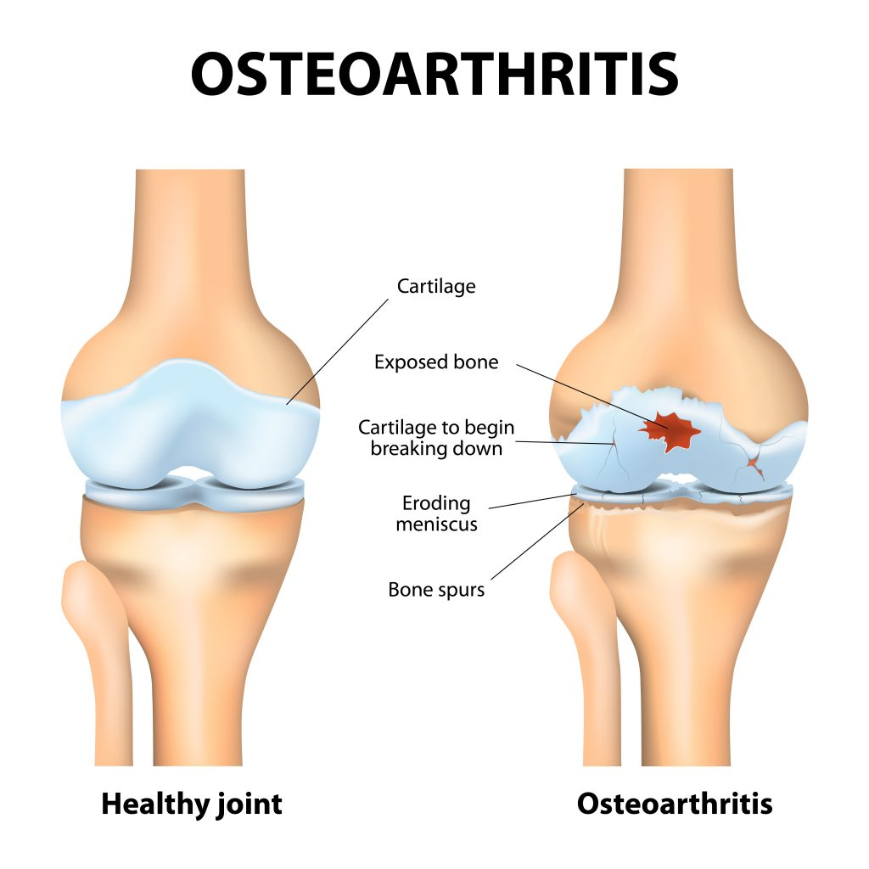

Fig.1 The difference between an OA and a Healthy knee

X-rays are commonly used to diagnose knee OA, which shows how far the bone and joint have deteriorated. KL scores are generally utilized to grade knee OA severity [3].

Early knee OA identification in a patient could guarantee appropriate medical attention and the correction of the problem. In this situation, medical imagery, like X-rays, may prove to be of great significance. As per the KL grading scale, osteoarthritis in a joint is graded according to its severity. Medical professionals use it extensively and consider it to be the gold standard. There are five severity levels in the KL grading system, each with its own set of variables.

A patient with knee OA is typically scanned to create an X-ray image, which is then manually evaluated for bone space narrowing, cartilage loss, and osteophyte formation. As per the KL grading scale, there is a definite correlation between the bone gap width and the knee OA grade.

TABLE I

The different KL-Scale grades[8]

|  |  |
| --- | --- |
| OA grading | Indication |
| Grade 0 | No definite OA existence within the joint |
| Grade 1 | Feasible osteophytic lipping, low possibility of joint space narrowing, and doubtful presence. |
| Grade 2 | Definite existence, the “joint space narrowing’s” definite possibility, and osteophytes' presence. |
| Grade 3 | Multiple osteophytes, the presence of sclerosis, a possible distortion of the bone end, and a moderate constriction of the joint space. |
| Grade 4 | Severe sclerosis, Large osteophytes, a clear bone end deformity, and a narrowing of the joint space. |

Joint inflammation, pain, and stiffness are common symptoms reported by patients. In addition to the patient's age, height, weight, and past injuries concerning the influenced joint, obesity, old age, and injury can also be important data points. Currently, this problem faces several challenges, including less precision owing to class imbalance, the use of older methods for localizing knee joints, and so on.

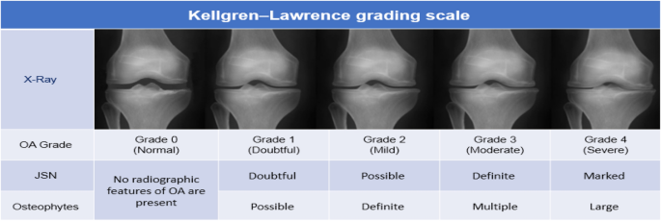

Fig.2 The various grades on KL-Scale [8].

We propose a technique for knee OA severity classification using modern object localization methods LIKE CNN. The focal loss function is also incorporated along with “data augmentation” to resolve the class imbalance issue. The rest of the article is organized as follows: The current state of the field's research is thoroughly covered in Section 2. The suggested ROI segmentation method, the different systems selected for the benchmarking analysis, and the datasets, as well as loss functions used to resolve the problem of class imbalance, are described in section 3. Section 4 concludes with recommendations for further study and a comparison of the models' performance.

Through the training of large amounts of data, DL (“Learning”) methods extract semantic data from images & complete end-to-end identification. The CNN (“Convolutional Neural Network”) is a feedforward NN that extracts images’ deep features and is commonly utilized in semantic segmentation, object detection, and classification [4-6].

II. Related Work

The research community has developed many automated screening approaches for knee OA. According to Minciullo and colleagues [10], knee joint X-ray images from the lateral view (in contrast to a frontal view) were partitioned using a RF (“Random Forest”) object detector, and a RF “Regression Voting Constrained Local” method was used to extract various knee joint forms as points, which are then put into a RF-based classifier that calculates both the existence and severity of knee arthritis. A two-step approach to quantifying knee OA severity was developed by Anthony et al. [8]. X-ray images were used to locate the knee joints in the 1st step, using a full CNN. By combining categorical cross-entropy as well as mean squared error loss, KL grades are classified from 0 to 4. Due to the combined outputs of multi-class classification and regression, this joint training uses a modified loss function to improve accuracy.

For the classification of knee OA severity, Aleksie et al. [15] proposed using CNN architectures. This CNN architecture is based on deep Siamese CNNs [14]. The proposed architecture uses lateral and medial parts of the image for both branches of the training phase. During the training phase, two images are compared based on their symmetry, with the two branches including the lateral part and the medial part. Based on KL grading, this model graded knee OA severity. By using GradCAM [16], the authors were able to visualize wear on cartilage recognized by the Siamese networks. [12] Kumar et al. used ML-supervised classifiers like SVM, KNN, and Random Forests (RFs) to detect knee OA on the KL grading scale, with KNN providing high precision. In addition, they found that radiographic measures such as mJSW (“Minimum Joint Space Width”), JSA (“Joint Space Area”), and osteophyte area facilitated accurate diagnosis.

According to Mahrukh et al. [17], OA of the knees can be detected on the basis of joint space width. To obtain the femur (lower bone), and tibial plateau (upper bone) they apply canny edge detection (CED) based on a template-based method. A joint space width is a “vertical distance” between the lower and upper edges of a joint. A predetermined threshold is used to detect OA; otherwise, it is not detected. Aside from plain radiographs, Chen et al. [4] used YOLOv2 to define the severity of knee osteoarthritis and detect the knee joint area. Detected knee joints have been cropped out of a cropped image. A classification algorithm was then trained on the localized knee joint images to predict the severity based on the KL Grades. The accuracy of KL Grade classification was also analyzed for different image classification algorithms, like Densenet, Resnet,

VGG16, and so on.

Using X-ray images and patient data, Abedin et al. [7] suggested a comparative modeling technique. A wide range of patient data was gathered, like BMI, weight, height, sex, age, as well as systolic and diastolic characteristics. Random forests and “elastic net regression” were used. Elastic Net is a weighted mixture of LASSO & ridge regression to choose variables with high predictive power. However, compared with other models, CNN gave the least RMSE value on X-ray images.

A DL-based end-to-end approach based on the localization of ROI and classification was proposed by Liu et al. [13]. To create Region proposals for Fast R-CNN, it uses “Faster R-CNN” as a baseline. We use a cross-entropy variant of focal loss, which addresses the issue of class imbalance. In this loss function, easy negative examples will be down-weighted and hard examples will be emphasized. Using a localized ROI with more pixels allows the RPN classification network to perform better when it has more anchors.

In their study [11], Kour et al. investigated numerous methods of identifying knee OA. There are three types of methods: vision-based, sensor-based, and hybrid methods. Furthermore, the authors provide a detailed overview of gait acquisition as well as feature representation methods. Additionally, they examine statistical metrics utilized to evaluate knee OA. Machine learning techniques were also discussed that could assist classify different knee OA severity levels on the basis of human gait. In addition, the Pearson correlation coefficient, ANOVA, chi-square, and other evaluation metrics were described. An X-Ray classification method for knee OA was proposed by Bayramoglu et al. [9] combining the JS2 (“Joint Shape-Joint Space”) descriptor with CNN. A JS2 descriptor and bone texture feature was added to a basic NN to determine the patient's Knee OA severity. In comparison to other methods that use edge detection methods and then calculate the distance between different points to determine knee OA severity, DL-based techniques produced the best results. Methods based on DL are further divided into two categories. One involves end-to-end models, which involve obtaining ROI, namely, knee OA classification and knee joint position, simultaneously. Alternatively, models are generally ensembles in which one model produces a localized ROI comprising the knee joint and then passes it on to another model that classifies knee OA severity.

We investigate the necessity for ROI segmentation by testing with state-of-the-art DL models. We also visualize the features of models with as well as without ROI segmentation to comprehend the role it plays.

III. Proposed work

We proposed a method to predict Knee Osteoarthritis using Deep Learning from knee X-ray images. The identification is depending on the VGG16 model classification, which corresponds to the OA severity. In this process, two phases are involved - ROI segmentation, which is an area around the right and left knee joints, followed by the usage of cutting-edge DL models. A variety of “ROI segmentation” algorithms are tested, including VGG16, Densenet, Resnet, etc. To obtain a highly accurate and faster CDSS to estimate knee OA severity, we must fix different issues like class imbalance and ROI detection. To balance the classes, oversampling/under-sampling methods and data augmentation are utilized. By segmenting the ROI, we can predict the severity of knee osteoarthritis by training deep-learning CNN models for KL-Grade classification. Whenever a new image is fed into the web application, the models are integrated so that they classify the KL grade and label the affected part of the image.

Osteoarthritis Initiative (OAI), a ten-year study aiming to advance research on detecting and treating knee OA, provided the dataset utilized for experimental validation of our method. A total of 4796 male and female patients with ages ranging from 45-79 were included in this study and their clinical data were collected at various times.

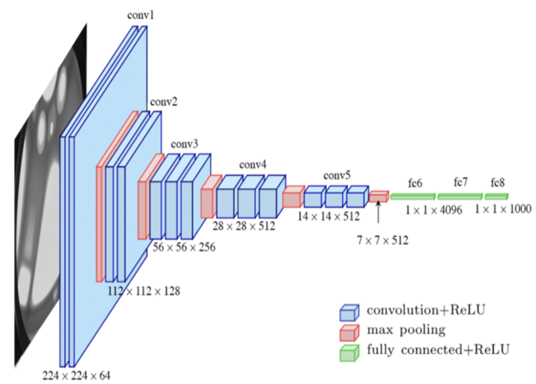

Fig.3 Proposed methodology

The VGG16 CNN architecture is considered one of the best vision model architectures to date. 13 “convolutional layers” and 3 fully linked layers make up the VGG-16. In VGG-16, the pooling layers are all “2×2 pooling layers” having a stride size of 2, whereas the “convolutional layers” are all “3×3 convolutional layers” with the same padding and a stride size of 1.

This study used only baseline (1st occurrence) X-rays from the entire archive. KL grades are assigned to 3,292 X-ray images of knee joints. The image distribution for every KL grade is shown in Table II.

TABLE II

Knee joint image dataset specifics & class-wise distribution.

|  |  |  |
| --- | --- | --- |
| OA grading | | Number of Images |
| Grade | 0 | 633 |
| 1 | 889 |
| 2 | 553 |
| 3 | 422 |
| 4 | 795 |

In the ROI identification stage, the CNN model is trained to partition the “knee joint” region. As the name suggests, CNN is the world's most famous and accurate one-shot object detection algorithm.

In each grid box, a confidence value, as well as dimensions of the bounding box, are predicted along with the object class present in that grid box. The segmented & cropped joint regions are trained to predict KL grades using many cutting-edge deep-learning models. The study experiments with

Densenet-201, Resnet-152, VGG16-BN, VGG16, and so on. Because OpenCV, Keras, and TensorFlow contain pre-trained models on ImageNet, transfer learning is possible with these models. The networks are trained using Focal Loss [18] to control the imbalanced class (Table II). With the focal loss, well-classified examples suffer less relative loss, making it easier to focus on examples that are hard to classify. Thus, the model turns its attention to the rare class when there is an imbalance in the classes. This equation defines the focal loss, which is driven by the variables t and a, and the cross-entropy loss is defined by pt.

The classes are balanced using oversampling/undersampling approaches and data augmentation. According to KL-Grade Yolov5 is utilized to partition the ROI, and cutting-edge DL models are trained to classify knee OA severity.

As a result of integrating the models into a “web application”, whenever a new image is put into the system, it will categorize the image's KL grade and identify the region that has been impacted by the image.

$FL(p)=-α(1-p)γlog(p)$ (1)

IV. Implementation SPECIFICS AND OUTCOMES

Throughout this section, we express the specifics of the implementation and details of the tests conducted to verify the suggested technique. The tests have been carried out on a local desktop computer which is equipped with a NVIDIA GEFORCE RTX GPU with 16GB of memory. A bilateral X-ray image of one limb is included in the OA dataset. The dataset is randomly divided into validation, training, as well as examination sets with a ratio of 7:1:2. Python and the Django framework are used to implement the models. The first part of the study, namely CNN, involves the manual annotation of 400 images using CVAT using drawing bounding boxes nearby the knee joint region in joints.

After training CNN, bounding boxes are automatically generated for “X-ray images” using the CNN model. The trained model weights are utilized to crop the knee joint area. Sample X-ray images segmented.

Accuracy, Recall, and IoU (“Intersection over Union”), were applied to assess the suggested approach experimentally. For evaluating algorithm performance, the IOU between manual annotations along with identified outcomes (Eq. 2) is calculated as the ratio between the “intersection” of original bounding boxes and identified bounding boxes and their union. KL grading is recommended for cropped-out knee joints with IoU values greater than 0.75

J (A, B) = |A∪B|

A∩B| (2)

A indicates the original bounding box’s area, B signifies the detected bounding box’s area, and J denotes Jaccard Index (IoU). Using modern image classification methods like VGG16, Densenet, Resnet, and so on, the “segmented ROI” are trained for KL grading. In Table IV you will find the results of the multiclass classification of KL grades. According to the suggested method, it attained a recall of 93 percent with the trained “YOLOv5” model. It was found that the VGG16 model had the best classification accuracy (69.8%). Additionally, Table V provides F metrics for VGG16 classification that correlate to various grades.

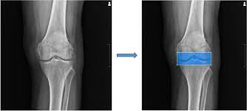

Fig. 4 Detection of Knee Joint area

TABLE III

Comparing state-of-the-art approaches with benchmarking Recall performance

|  |  |
| --- | --- |
| Approaches | Recall (IoU>0.75) |
| Chen et al (2019) (YOLOv2) [4] | 92.2% |
| Antony et al (2017) [2] | 89.2% |
| Proposed Method (CNN) | 93% |

TABLE IV

A comparison of multi-class classification accuracy based on focal loss models.

|  |  |
| --- | --- |
| Model | Accuracy |
| Densenet-201 | 68.5% |
| Resnext101 32x8 | 65.7% |
| Resnet-152 | 66.7% |
| VGG16-BN | 68.2% |
| VGG16 | 69.8% |

In the version shown in Table VI, the accuracy obtained is compared to existing work. Results obtained with the suggested approach are found to be on par with those obtained with existing KL-Grade classification techniques. This study analyzes ROI, and segmentation qualitatively to understand their importance. Original knee x-ray along with ROI segmented images are used to train the top-scoring classification mode.l There is a large performance difference between the 1st method (without cropping) at 57.2 percent, and the suggested method (with cropping), at 69.8%.

GradCAM was also used to generate heat maps. These heat maps display the regions that the DL considers when classifying a photo as belonging to a certain category. GradCAM interprets each neuron's decision based on gradient information from the last convolutional layer. Figure 5 (left) displays the heat maps for the method, which entails categorizing entire X-ray images, for several classes of

TABLE V

Various grades are represented by VGG16 F-measures.

|  |  |  |  |
| --- | --- | --- | --- |
| Grade | F1 | Recall | precision |
| 0 | 0.78 | 0.83 | 0.74 |
| 1 | 0.34 | 0.33 | 0.36 |
| 2 | 0.68 | 0.69 | 0.66 |
| 3 | 0.69 | 0.64 | 0.74 |
| 4 | 0.84 | 0.88 | 0.80 |

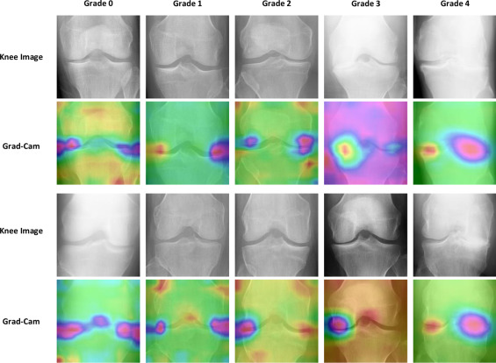

Fig. 5: Grad CAM heat-maps for the trained models for the whole x-ray (1 to 2 columns) and the ROI subdivided (3 to 4 columns).

images, while ROI-segmented X-rays can be seen in Figure 5(right). According to these heat maps, with the entire X-ray image classification, the heat regions are spread throughout the image (other than the region of the knee joint), making it difficult for the model to focus on a particular spot. ROI-segmented images overcome this problem. As a result of knee osteoarthritis, the “heat areas” are located at the boundary between the 2 bones inside the knee joint. By considering the correct area for labeling an image, the model is making the right decision. Thus, cropping the ROI first and then classifying instead of directly classifying justifies the higher accuracy. Furthermore, the visualization aids the orthopedist in developing trust in DL-based CDSS.

TABLE VI

Using modern techniques to benchmark the proposed approach

|  |  |
| --- | --- |
| Techniques | Accuracy |
| Proposed Technique | 69.8% |
| Liu et al (2020) [7] | 74.3% |
| Chen et al (2019) [4] | 69.6% |
| Tiulpin et al(2018) [12] | 66.7% |
| Antony et al (2017) [2] | 63.9% |

V. Conclusion and future work

It is crucial to detect knee joint disorders early so that clinical decisions can be made with the best possible outcome, as well as decrease the related risks; however, “manual screening” is difficult and time-consuming. In the present article, we present an approach for “OA severity classification” on the basis of ROI segmentation for the development of DL-based CDSS that is based on ROI segmentation. On the basis of the outcomes, it is possible to conclude that ROI segmentation not only helps DL models perform better but also makes it easier for people to have trust in “intelligent healthcare” systems after the results have been obtained. The class imbalance issue is solved using the focal loss, which increases the estimated performance of the suggested as a result of solving the imbalance problem. There are also other techniques, such as gait analysis, which can also be integrated into the CDSS to raise the precision and assist the “medical practitioners” in making better decisions based on additional variables, like gender, age, etc., to be considered.

References

1. Long, Huibin, et al. “Burden of osteoarthritis in China, 1990 – 2017: findings from the Global Burden of Disease Study 2017,” The Lancet Rheumatology, vol. 2, no. 3, pp. e164-e172, 2020.
2. Li, M. H., et al. “Regenerative approaches for cartilage repair in the treatment of osteoarthritis,” Osteoarthritis and cartilage, vol. 25, no. 10, pp. 1577-1587, 2017.
3. Kellgren, Jonas H., and JS1006995 Lawrence. “Radiological assessment of osteo-arthrosis,” Annals of the rheumatic diseases, vol. 16, no. 4, pp. 494, 1957.
4. Li, Zhenliang, et al. “Deep Multi-Instance Learning with Induced Self-Attention for Medical Image Classification,” 2020 IEEE International Conference on Bioinformatics and Biomedicine (BIBM), IEEE, 2020.
5. Su, Ying, Dan Li, and Xiaodong Chen. “Lung nodule detection based on faster R-CNN framework,” Computer Methods and Programs in Biomedicine, vol. 200, pp. 105866, 202.
6. Liu, Ning, Liangliang Liu, and Jianxin Wang. “Local Adaptive U-net for Medical Image Segmentation,” 2020 IEEE International Conference on Bioinformatics and Biomedicine (BIBM). IEEE, 2020.
7. Abedin, J., Antony, J., McGuinness, K., Moran, K., O’Connor, N., Rebholz-Schuhman, D., Newell, J.: Predicting knee osteoarthritis severity: comparative modeling based on patient’s data and plain x-ray images. Scientific Reports 9 (04 2019).
8. Abedin, J., Antony, J., McGuinness, K., Moran, K., O’Connor, N., Rebholz-Schuhman, D., Newell, J.: Predicting knee osteoarthritis severity: comparative modeling based on patient’s data and plain x-ray images. Scientific Reports 9 (04 2019)
9. Bayramoglu, N., Nieminen, M.T., Saarakkala, S.: A lightweight CNN and joint shape-joint space (js2) descriptor for radiological osteoarthritis detection In Medical Image Understanding and Analysis.- 24th Annual Conference, MIUA 2020, Oxford, UK, July 15-17, 2020, Proceedings. vol. 1248. Springer (2020)
10. Chen, P., Gao, L., Shi, X., Allen, K., Yang, L.: Fully automatic knee osteoarthritis severity grading using deep neural networks with a novel ordinal loss.Computerized medical imaging and Graphics: the official journal of the Computerized Medical Imaging Society 75, 84–92 (2019)
11. Kour, N., Gupta, S., Arora, S.: A survey of knee osteoarthritis assessment based on gait. Archives of Computational Methods in Engineering 28 (01 2020)
12. Kumar, A., Saxena, P.: Quantification of cartilage loss for automatic detection and classification of osteoarthritis using machine learning approach.In: 2019 10th International Conference on Computing, Communication and Networking Technologies (ICCCNT). pp. 1–6 (2019)
13. Liu, B., Luo, J., Huang, H.: Toward automatic quantification of knee osteoarthritis severity using improved faster r-cnn. International Journal of Computer Assisted Radiology and Surgery 15 (01 2020)
14. Mehmood, A., Maqsood, M., Bashir, M., Shuyuan, Y.: A deep siamese convolution neural network for multi-class classification of alzheimer disease. Brain Sciences 10(2) (2020)
15. Tiulpin, A., Thevenot, J., Rahtu, E., Lehenkari, P., Saarakkala, S.: Automatic knee osteoarthritis diagnosis from plain radiographs: A deep learning-based approach. Scientific Reports 8 (01 2018)
16. Selvaraju, R.R., Cogswell, M., Das, A., Vedantam, R., Parikh, D., Batra, D.: Grad-cam: Visual explanations from deep networks via gradientbased localization. In: 2017 IEEE International Conference on Computer Vision (ICCV). pp. 618–626 (2017)
17. Saleem, M., Farid, M.S., Saleem, S., Khan, M.: X-ray image analysis for automated knee osteoarthritis detection. Signal, Image, and Video Processing 14 (09 2020)
18. Mulyanto, M., Faisal, M., Prakosa, S.W., Leu, J.S.: Effectiveness of focal loss for minority classification in network intrusion detection systems. Symmetry 13(1) (2021)